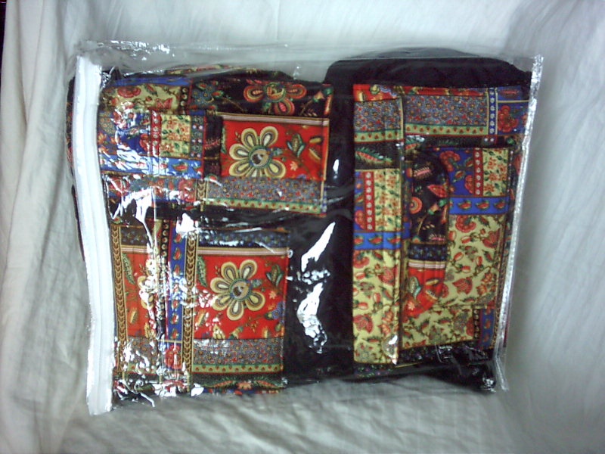
TEND-A-TOT™ PRODUCT USE INSTRUCTIONS

The Tend-A-Tot™ arrives in clear packaging with a zipper closure to insure that it is clean and fresh. It has been inspected to make sure that it has been properly constructed and that the extras (Bib & Changing Pad/Furniture Protector/Place Mat) have been included.

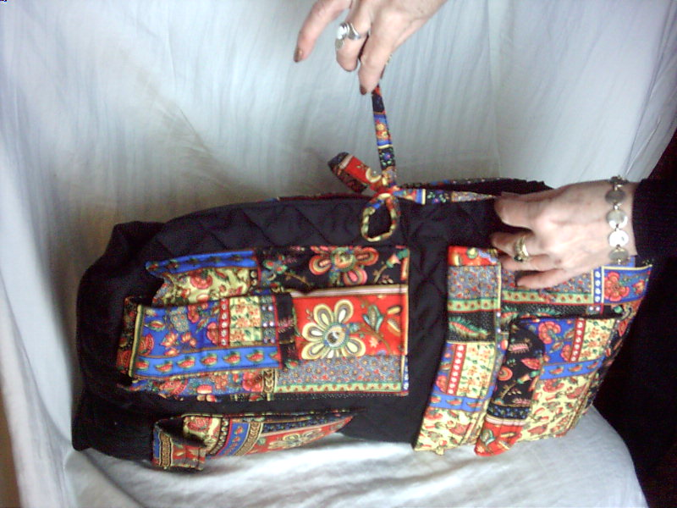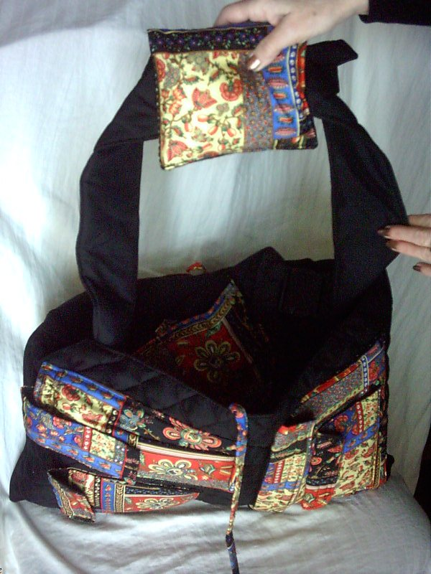
The Tend-A-Tot™ has a main tie closure. To open the Tend-A-Tot™ for use, simply untie the bow at the top. This will allow access to the Main Carrying Shoulder Strap.

USING THE TEND-A-TOT™ AS A DIAPER BAG/TOTE
(Figures 1-5)

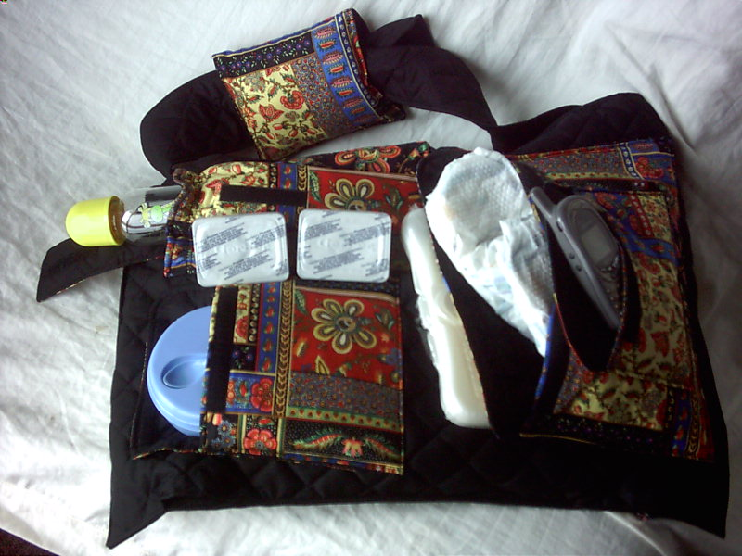
Fig. 1

Fig. 1 - The Diaper Bag portion of the Tend-A-Tot™ has six outside pockets with easy access and plenty of space for both child and caretaker to pack necessities for a day’s outing, a short visit or a trip.

The three pockets shown above right hold a cell phone, diapers and/or caretaker’s wallet, keys, small purse, etc. and a container of wet wipes.

The pocket at top left holds two containers of baby food and an 8 oz. baby bottle (or two 4 oz. bottles). The tab closure is adjustable, allowing for a perfect fitting closure, along with an elasticized top on the pocket itself.

The two pockets at the bottom left hold the matching baby bib (which is included with your Tend-a-Tot™) and accommodates a baby dish and spoon in which you may store dry formula, dry cereals, etc.

Note: As the occasion calls for and the needs of the child and caretaker dictate, these pockets offer the ideal setup for arrangement of and immediate access to both yours and your child’s necessities.

Tend-A-Tot™ Made in U.S.A. by Punim Products, LLC WWW.TENDATOT.COM

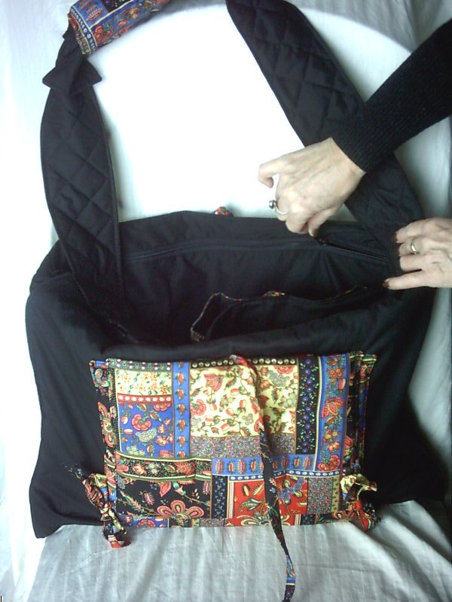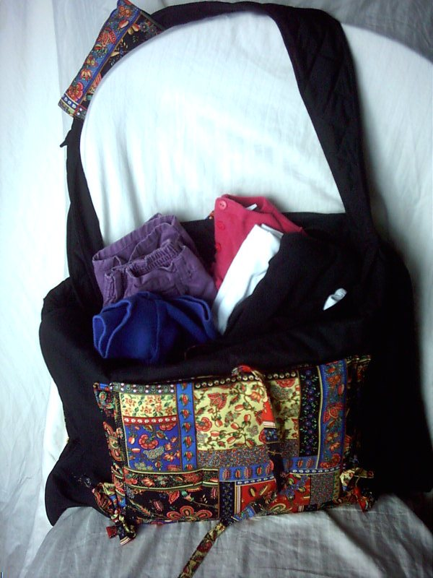
Fig. 2 Fig. 3

Fig. 2 - On the inside of the Tend-A-Tot™, you will find a large zipper. This zipper accesses the inside of the diaper bag, a roomy space to fill with baby’s change of clothing, a sweater or jacket and any other item which is needed for a day’s outing, a visit or a trip.

Fig. 3 - Here you see the diaper bag holding three pairs of pants and three long-sleeved shirts. And there is still room for more items!!!

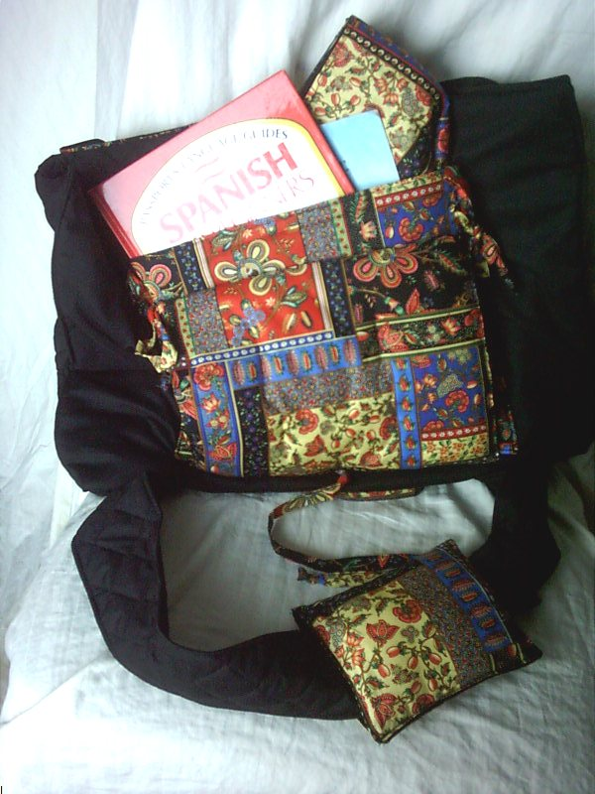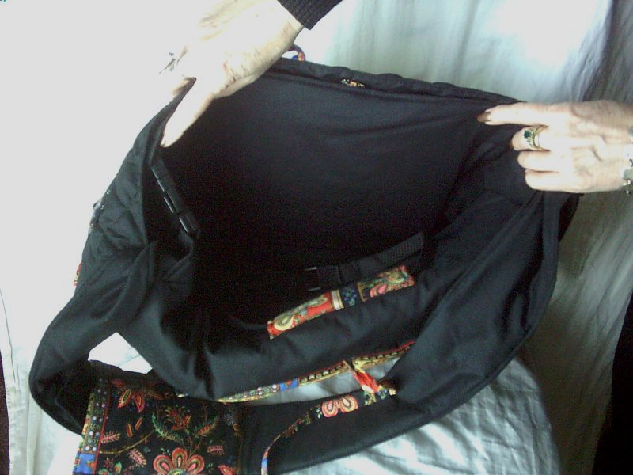
Fig. 4 Fig. 5

Fig. 4 - Besides all those pockets on the Diaper Bag and all that room inside the Diaper Bag for clothing, etc., here you have a view of the other side of the Tend-A-Tot™ with yet more storage space.

Behind the Semi-Attached Pillow, is a generous-sized pocket; in this pocket, you will find the matching Changing Pad/Furniture Protector that comes with the Tend-A-Tot™.
This is a great place to carry coloring books, a children’s book or two and even one for you. Also a great pocket for extra diapers! A strong Velcro closure secures these items in place.

Fig. 5 - You will, perhaps, discover this by yourself; but it merits mention, anyway. For a long trip or an occasional outing that requires more things to be toted along for you and baby, you may utilize the space inside the Tend-A-Tot™, itself, to put more stuff. This is especially great, when you are going on overnights and can empty this part out on arrival at your destination and utilize the rest of the Tend-A-Tot™ as usual.
Limited Warranty: Tend-A-Tot™ is warranted against defects in material and workmanship for thirty days from date of purchase. This warranty does not cover damage resulting from accident, abuse or lack of reasonable care while in use.

Product Content & Care: All materials are cotton, cotton blends and/or synthetic materials. Machine Wash with like colors on warm. Use a mild soap and no bleach. Tumble-dry on low.

USING THE TEND-A-TOT™ AS
A CHAIR CONVERTER
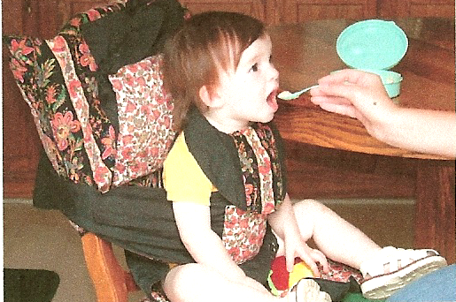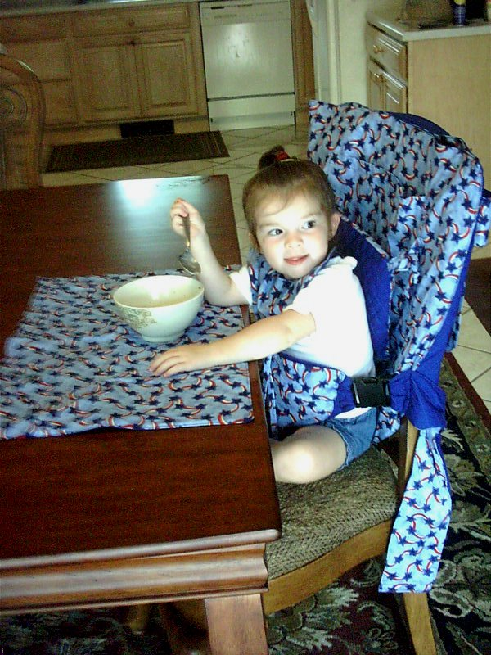
Fig. 6 Fig. 7

Fig. 6 & 7 - Depending on the age and strength of your child, you will find that baby will begin utilizing this feature of the Tend-A-Tot™, perhaps as early as three months of age. And, again, depending on the individual child, a young child may continue using it as a Chair Converter well up to and beyond age 3. It is especially useful at this age to keep your 3-year-old contained in a restaurant, where they often get down from the table and wander.

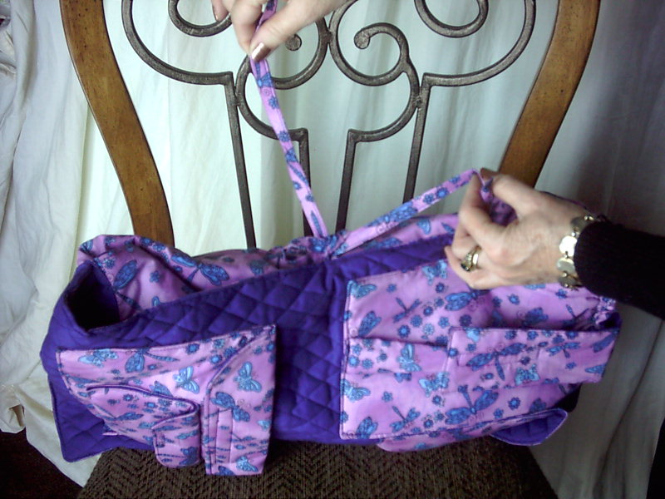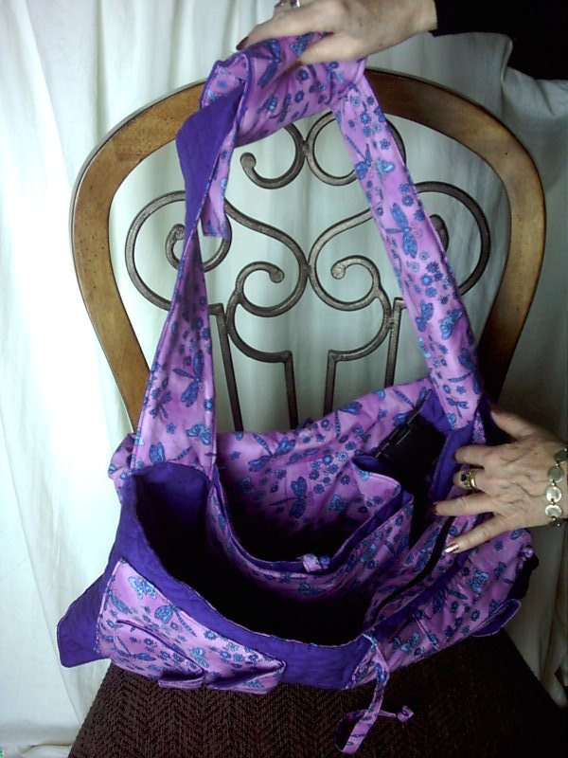
Step 1 Step 2
Step 1: Open the Tend-A-Tot, untying the main ties.
Step 2: Pull out the main carrying strap.
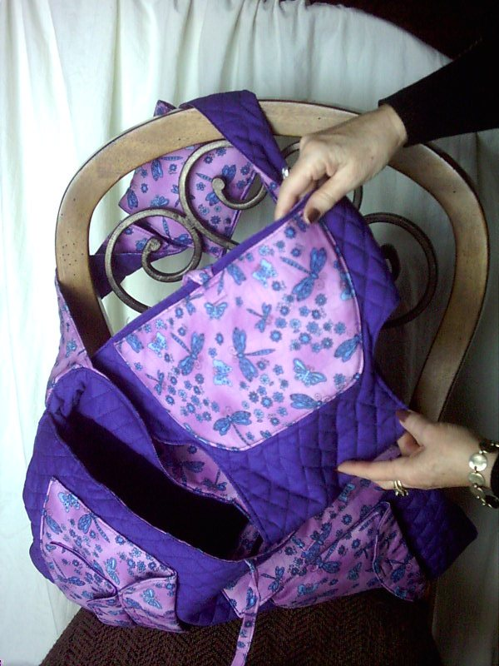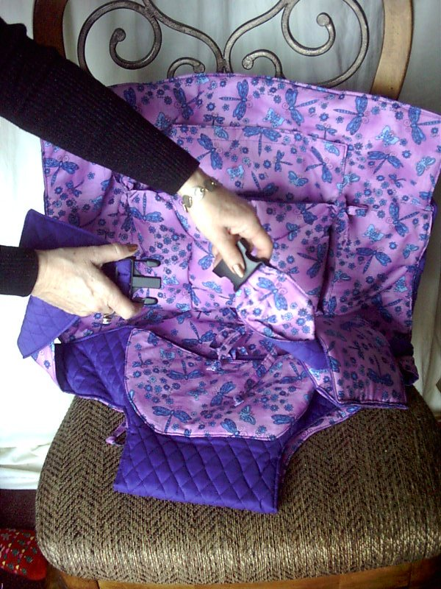
Step 3 Step 4
Step 3: Pull out the Chair Seat.
Step 4: Undo the Main Carrying Strap Release Buckle.

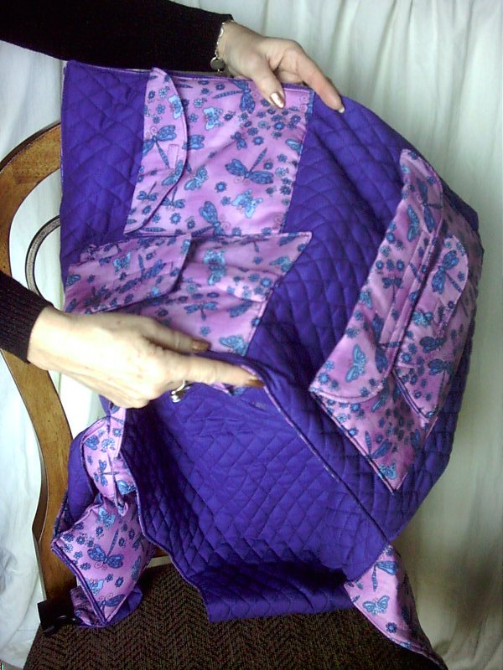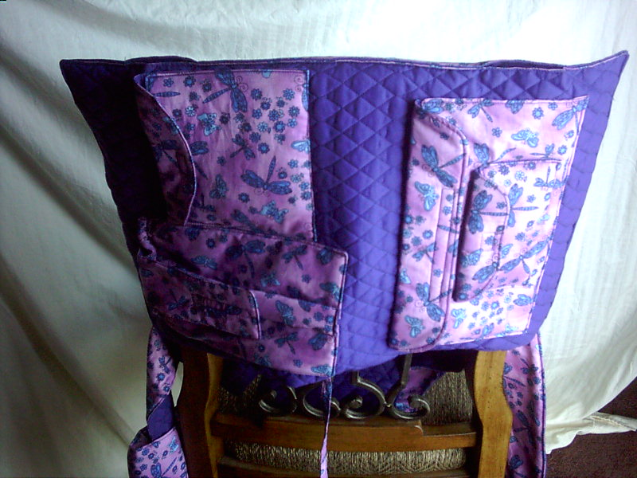
Step 5 Step 6

Step 5: Turning the Tend-A-Tot around with the Diaper Bag Pockets facing you, you can now access the portion of the Tend-A-Tot™ that allows you to slip it over the back of a chair.
Step 6: Back View: Slip the Diaper Bag over the back of the chair. Note: There are two buttonhole openings at the top of the Tend-A-Tot™, which allow use with spindle-back chairs. Simply allow the spindles to pass through these two openings.

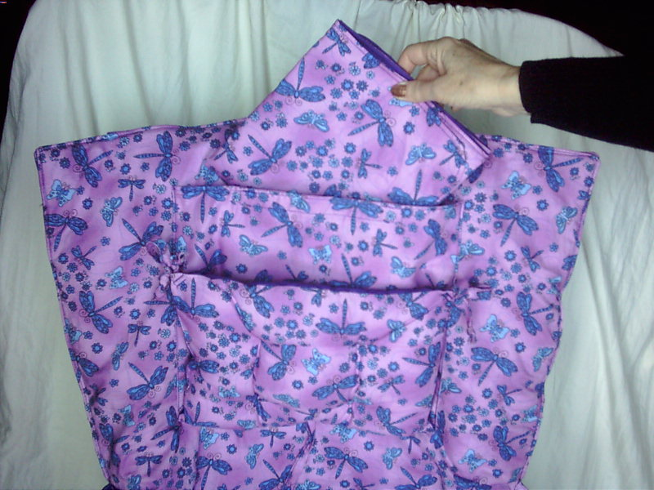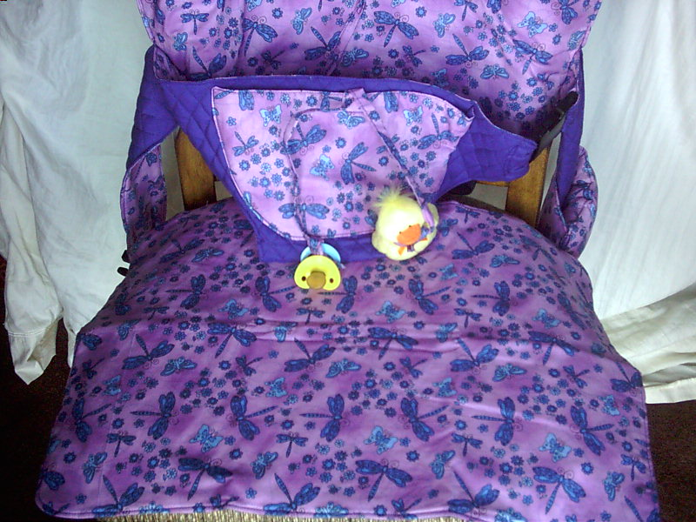
Step 7 Step 8

Step 7: Remove the Changing Pad/Furniture Protector from the pocket behind the semi-attached pillow.
Step 8: Place the Changing Pad (now used as a Furniture Protector) over the seat of the chair. This will put your host/hostess at ease, especially when placing your child on a fabric-covered dining chair.

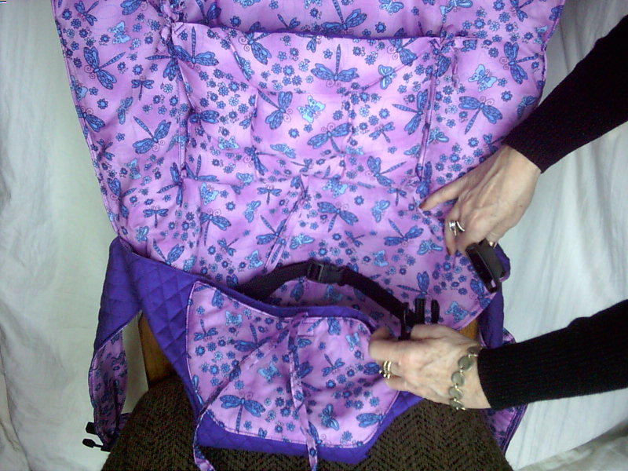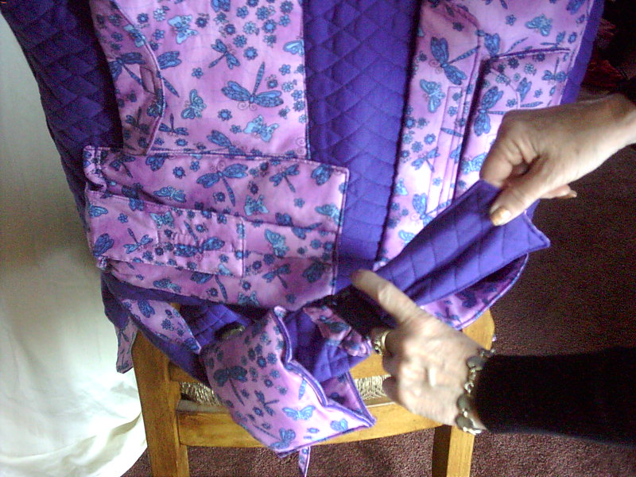
Step 9 Step 10

Step 9: Now you are ready to place your child in the Tend-A-Tot™. If not already open, open the Side-Release Buckle. There is a second Side-release Buckle on the Safety Strap. Place child, putting the right leg through the side opening of the Tend-A-Tot™. Secure the child with the Safety Strap, adjusting to a comfortable yet secure position. Then close the main Side-Release Buckle. Note: Never leave the child unattended!!! Continue securing the child as follows:

Step 10: Go around behind and close the Main Carrying Strap Side Release Buckle. Adjust the strap to secure the child tightly. This strap may be tied in place instead of buckled.
Word of Warning!!! As children grow, they have a tendency to use their feet to push against an object. When using the Tend-A-Tot™ as a Chair, be sure that the child’s feet cannot reach the table and push back!!!

THE TEND-A-TOT™ AS AN
UMBRELLA STROLLER CONVERTER
(Figures 8 & 9)
(Repeat Instruction Steps 1-5, on page 2, for stroller use.)
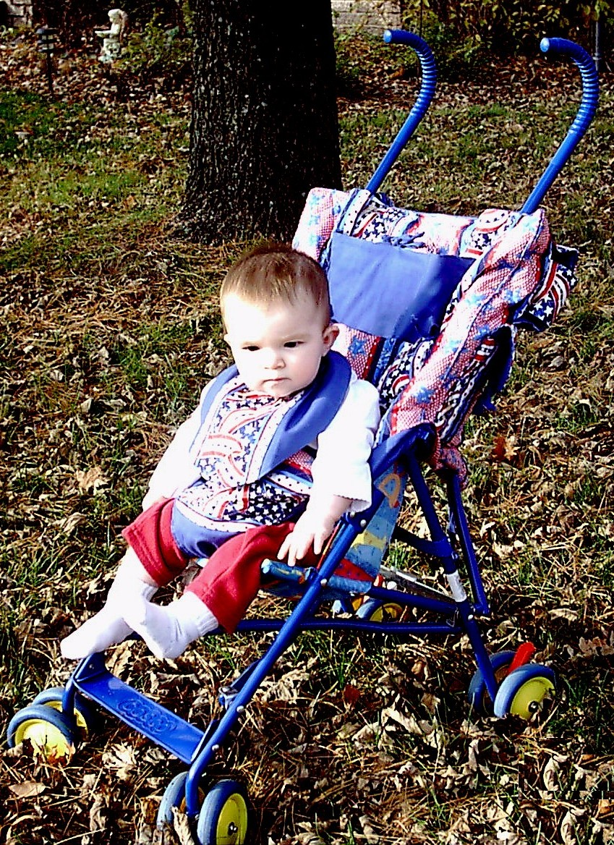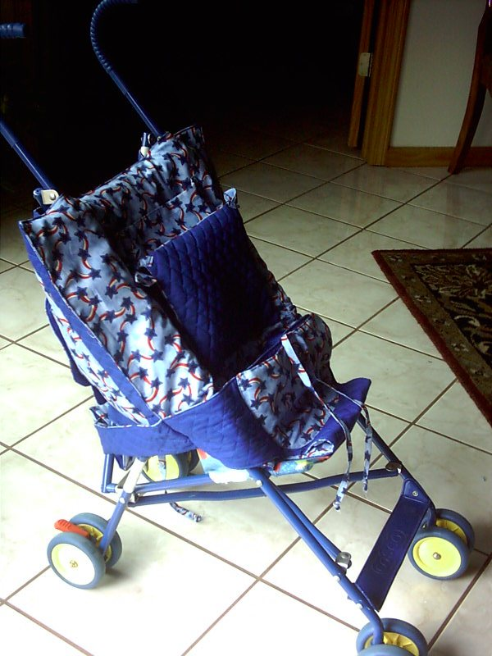
Fig. 8 Fig. 9

Fig. 8 & 9 - You are now ready to place the Tend-A-Tot™ over the two curved handles of the umbrella stroller, passing the handles through the two “buttonhole” openings at the top of the diaper bag. Pull the seat portion down to conform to the seat of the stroller. The diaper bag will fit perfectly at the back of the stroller as you slide the Tend-A-Tot™ down into position.
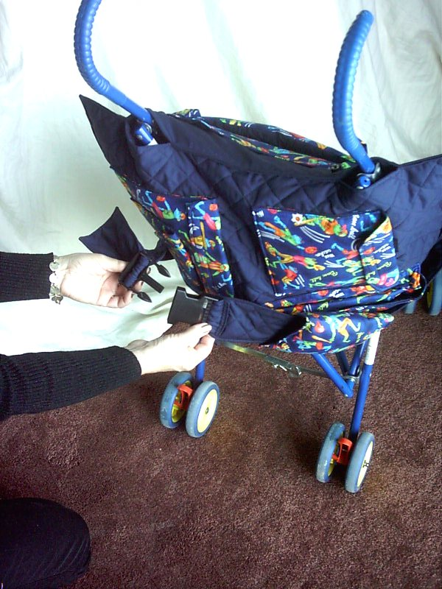
Fig. 10
Go around behind and close the Main Carrying Strap Side Release Buckle. Adjust the strap to secure the child tightly.

THE TEND-A-TOT™ AS A
BABY/CHILD CARRIER

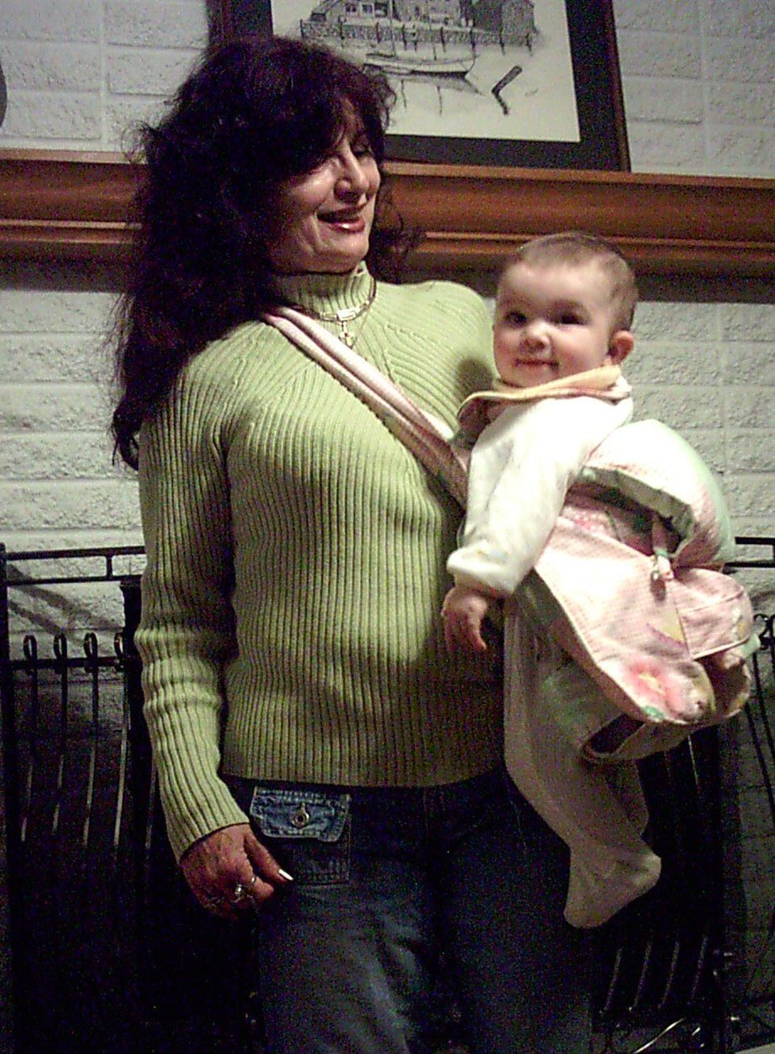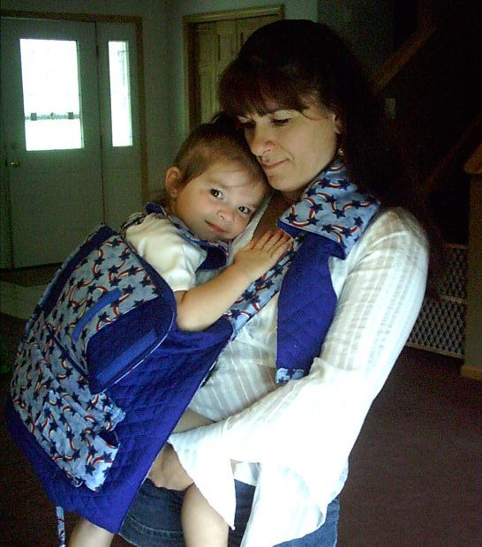
Fig. 11 Fig. 12

Fig. 11 & 12 - Depending on the age and size of your baby, the method of placing baby in the Tend-A-Tot™ and on your body varies. With an infant, the easiest way is to place the open Tend-A-Tot™ on a safe, flat surface, having the product in the reverse-seat position. (Simply reach your hand in and pull seat out to reverse.) This will allow easy access to the outside of the diaper bag, while the child is being carried in the Tend-A-Tot™. Secure the Safety Belt, adjusting it to fit snuggly but not too tightly. Then close the Side-Release Buckle. With a little experimenting, you will discover the exact length of adjustment for the Shoulder Carrying Strap, allowing the baby to rest comfortably for you on your hip. This can be adjusted, preferably, before placing the baby on your body. Slip the strap over your head and crosswise over your body.

The Tend-A-Tot™, during this usage, provides an excellent way of nursing or giving baby a bottle in a public or semi-private environment. Simply lift the Diaper Bag portion up around baby and use the Changing Pad/Furniture Protector, if extra cover is needed for privacy. Not only will this allow you and baby comfort at feeding time, but most importantly, it greatly reduces outside noises and distractions for baby, which would otherwise interfere at this personal time.

Product Warning: Never leave child unattended in the Tend-A-Tot™. Place product on stable chair, cart or stroller. Child must have weight resting on chair/seat. This product is not a replacement nor substitute for any child safety device and is to be used only in accordance with product use directions.

THE TEND-A-TOT™ IN USE FOR
SHOPPING CART COMFORT

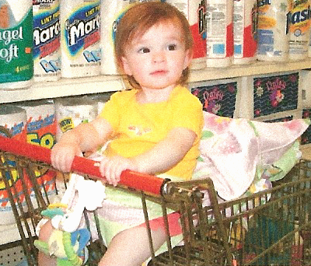
Fig. 13
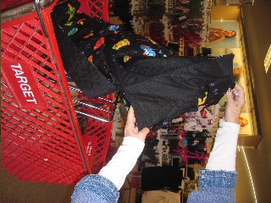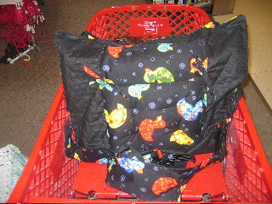
Fig. 14 Fig. 15

Fig. 13, 14 & 15 -Turning the Tend-A-Tot around with the Diaper Bag Pockets facing you, you can now access the portion of the Tend-A-Tot™ that allows you to slip it over the seat-back of the shopping cart.

However, placement of the Tend-A-Tot ™ on the shopping cart depends on whether baby is already being carried on your body in the Child Carrier Position (with the Tend-A-Tot™ seat in reverse position and the Diaper Bag outside exposed as it falls back). In this instance, with the Main Carrying Shoulder Strap still in place on your body, lift baby into the shopping cart seat, Tend-A-Tot™ and all. Then unbuckle the Main Carrying Strap and reposition it through and around the back of the shopping cart seat, adjusting it to fit baby snuggly in place. Place the Changing Pad/Furniture Protector over the shopping cart handle for extra comfort and sanitation.

THE TEND-A-TOT IN USE ON A HIGHCHAIR

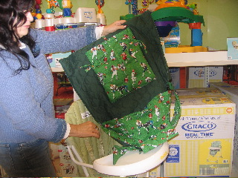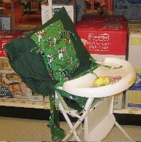
Fig. 15 Fig. 16

Fig. 15 & 16 - (Follow Steps for Chair Converter on Placement P. 2) Although the Tend-A-Tot™ eliminates the use of a conventional highchair, there might be an occasion when you are offered the use of one in a restaurant. Naturally, these chairs are, at best, less then sanitary and, by nature hard and uncomfortable. So, here you have the perfect solution! Place your Tend-A-Tot™ on the highchair in the same manner that you would over a conventional dining chair. And be sure to use the Changing Pad/Furniture Protector as a placemat on the highchair tray!

